OREGON INSTITUTE OF TECHNOLOGY
Computer Systems Engineering Technology Department
CST 315 – Embedded Sensor Interfacing I/O
Lab 3 - Basic Op Amps
Name: Chris Thomas Score: ____________
Partner: Justin Brumble
PURPOSE:
The purpose of this lab is to investigate the behavior of Operational Amplifiers (Op Amps) in several configurations.
EQUIPMENT AND SUPPLIES:
- Oscilloscope with probes
- Function generator with BNC-to-alligator clip cable
- Power Supply with two chnnls
- Digital Multimeter (DMM) with probes
- Resistors: 3 – 1K, 2 – 47K, 1-10K, 2 – 22K, 1 – 100 K
- 1 – LM358 Op Amp
- Breadboard

LM358 PIN CONNECTIONS Looking Down at the Top of the IC
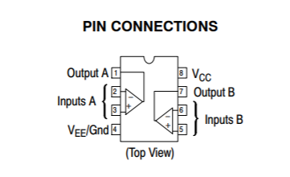
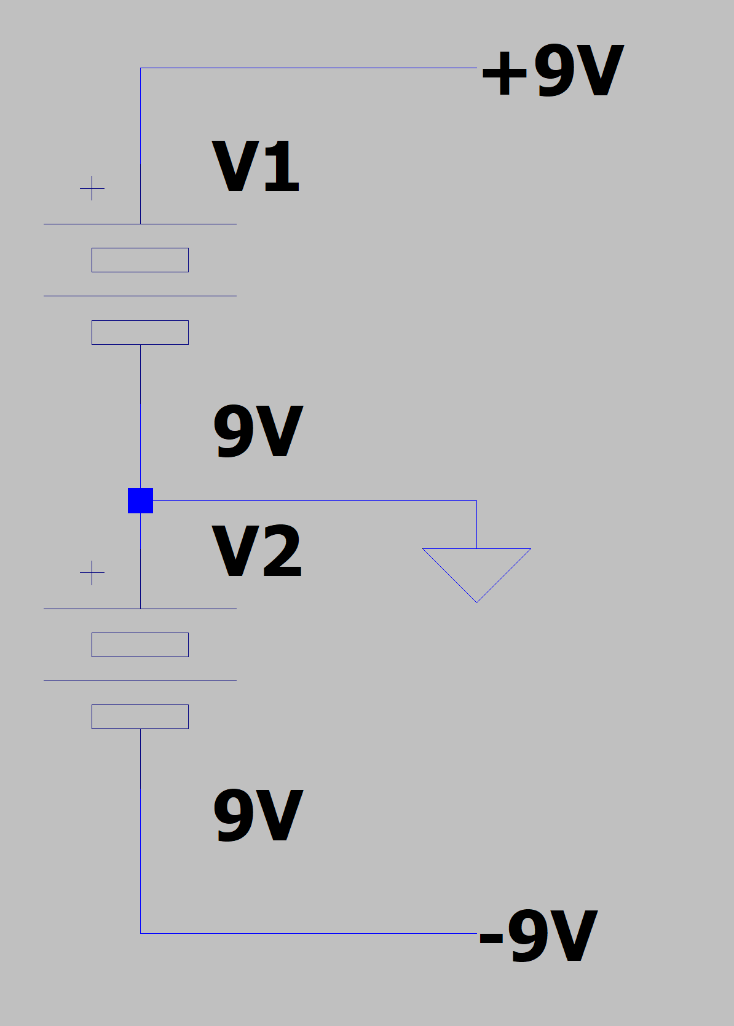
PROCEDURES:
- Turn on the Scope.
- Connect the two power suplly channels together by connecting the negative terminal of one channel to the positive terminal of the other chnnel. These two connected terminals will be the ground for the circuits. The two remaining power supply terminals will be the positive voltage and the negative voltage sources for the circuits.

- Build the Voltage Divider Circuit in Figure 1. Note that it is connected to +9V and Gnd of the batteries. Make sure that the Gnd connection in Figure 1 is connected to the ground of the opamp circuit.

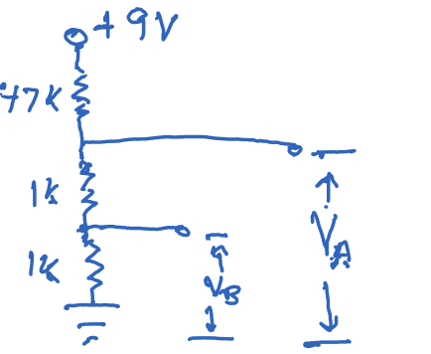
Figure 1

- Build the circuit shown in Figure 2 using the LM358 Op Amp. R1=22K, R2=100K. Measure and record the resistances of R1 and R2. R1=______21.8k____;R2=___99.3k______
Connect the input of the opamp (Vin) to Vb of the voltage divider. Measure and record Vin while connected to the opamp input ____0.176V______. Measure and record
Vout _____-0.813V_____.
Calculate Vout=_____-0.802V____ using the equation given in class. How does the calculated Vout compare to the measured value of Vout?
The measured value and the calculated value are within tolerance of each other.
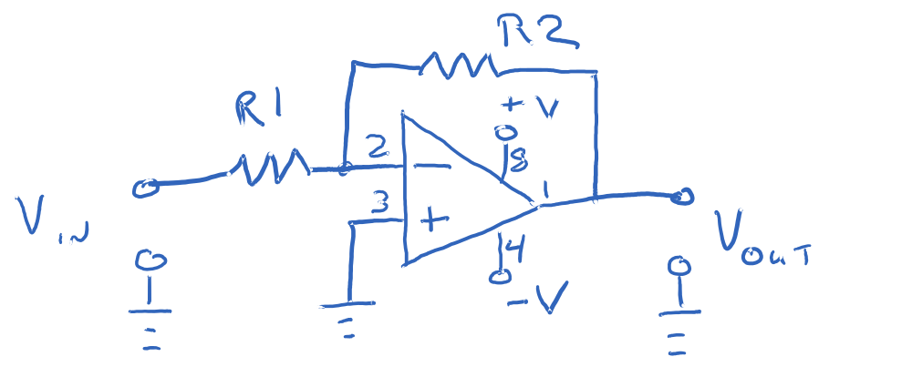
Figure 2

- Rebuild the circuit in Figure 2 with R1=1K and R2=4.7K. Measure and record the resistance values of R1 ___.999k_______and R2_____4.73k_____.
With Vb connected to the input of the opamp measure and record Vin = _____0.091V______ and
Vout = ____-0.445V________.
Calculate Vout=_____-0.43V_____ with the equation given in class. How does the calculated Vout compare to the measured Vout? Explain your answer.

- Build the circuit in Figure 3. R1=R2=22K, R3=100K
Measure and record the values of the resistors R1=___21.93k______, R2=____21.93k_____. Connect Vb from the voltage divider to R1, and Va to R2. Measure and record the values of Va=__0.331V______, Vb=___0.162V_____ and Vout = -2.265V_____ after Va and Vb are connected to R1 and R2.
Using the measured values of the resistors, Va, and Vb calculate the value of
Vout = ______-2.24V____. How does the measured value of Vout=_____-2.265V____ compare to the calculated value of Vout?
The measured value and the calculated value are within tolerance of each other.
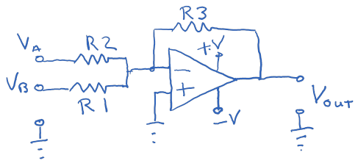

Figure 3

- Build the circuit in Figure 4. R1=100K, R2=22K
Measure and record the values of the resistors R1=___99.3k______, R2=___21.93k______. Connect Vb from the voltage divider to the non-inverting input (Vin) of the opamp. Measure the value of Vb = ____0.184V______ after it is connected to the amplifier.
Use the measured values of the resistors and Vb to calculate the value of Vout = ____1.01V____. Measure Vout=___1.005V______. How do the calculated and measured values of Vout compare?
The measured and calculated values are practically the same.

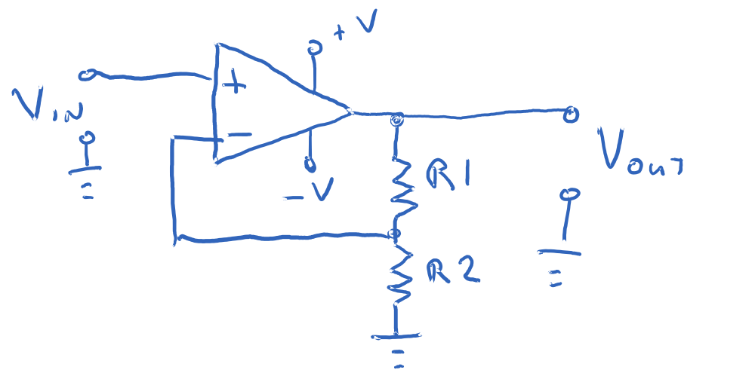
Figure 4

- Build the circuit in Figure 5 with R1 = 1K and R2 = 10K. Configure the signal generator as follows:
A. Set the FUNCTION to a sine wave.
B. Set the frequency to 100 Hz.
C. Set the AMPLITUDE to 0.1Vp and OFFSET to 0V DC.

Connect the signal generator (Vin) to the input of the opamp (R1). Use Chan. 1 of the scope to monitor the output of the signal generator and Chan. 2 of the scope to monitor Vout. Using the value of 1K for R1 and 10K for R2 calculate the voltage gain of the amplifier and Vout. How does the calculated value of Vout = ____-2V____ compare to the observed value of Vout=___-1.96V____?
Sketch the signal from the signal generator (V1) and Vout. Be sure to indicate voltage on the vertical axis. Show the phase relationship between Vin and Vout
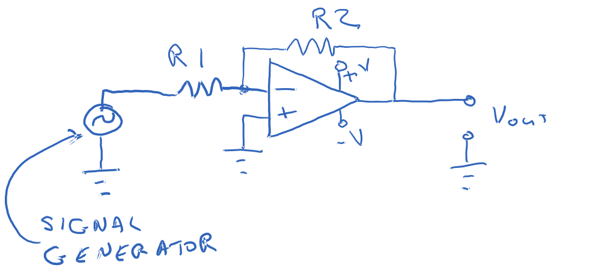
Figure 5

- Repeat step 8 with the amplitude of the signal generator set to 1 Vp. Sketch Vin and Vout with voltage on the vertical axis. Did changing the input voltage change the results? Explain.
Yes it no longer a gain of 10 but now 16.
This is because the opamp is being powered by 9V which limits it to that.
